

# **Data Communication & Computer Networks Lab**

**Submitted by: Submitted to:**

**NAME : Rahul Gusain Ved Prakash Bhardwaj**

**SAP: 500084143**

**ROLL NO.: R214220900**

**BATCH: 1 DevOps**

**EXPERIMENT 5**

**Simulation using Packet Tracer**

Download Cisco Packet Tracer

<https://www.netacad.com/courses/packet-tracer>

Screenshots :-

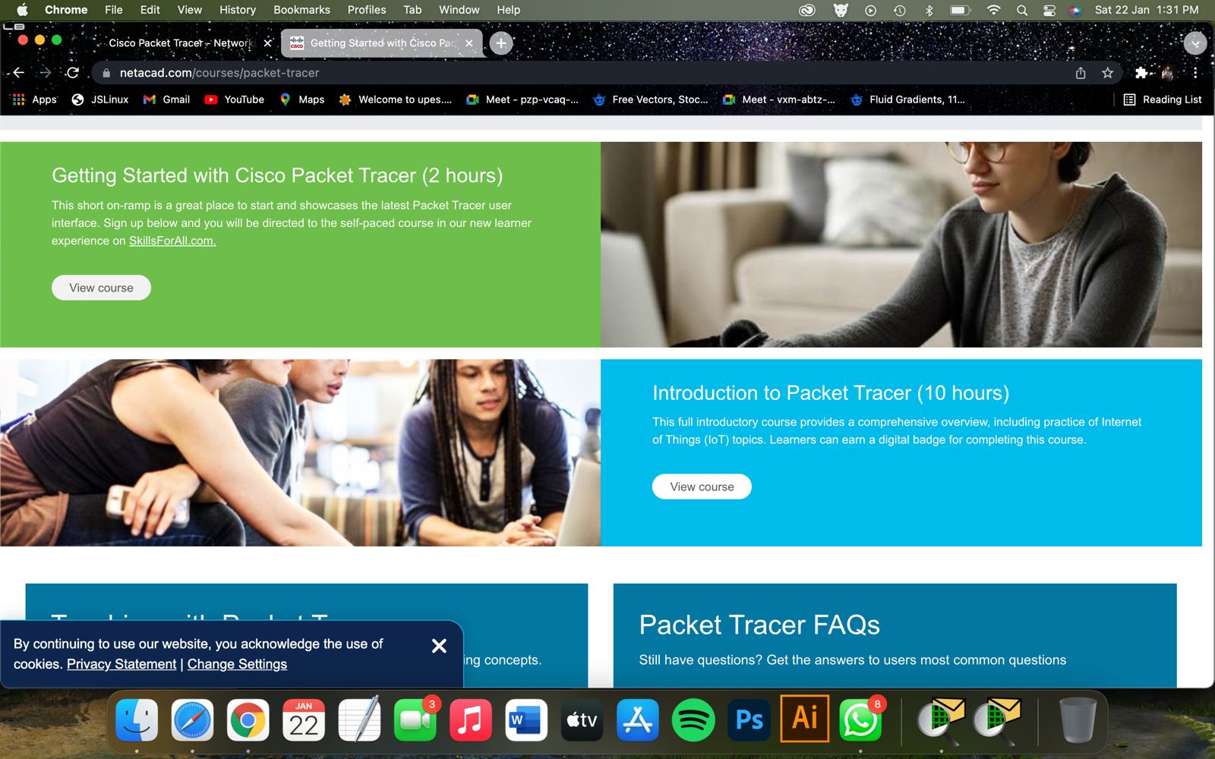

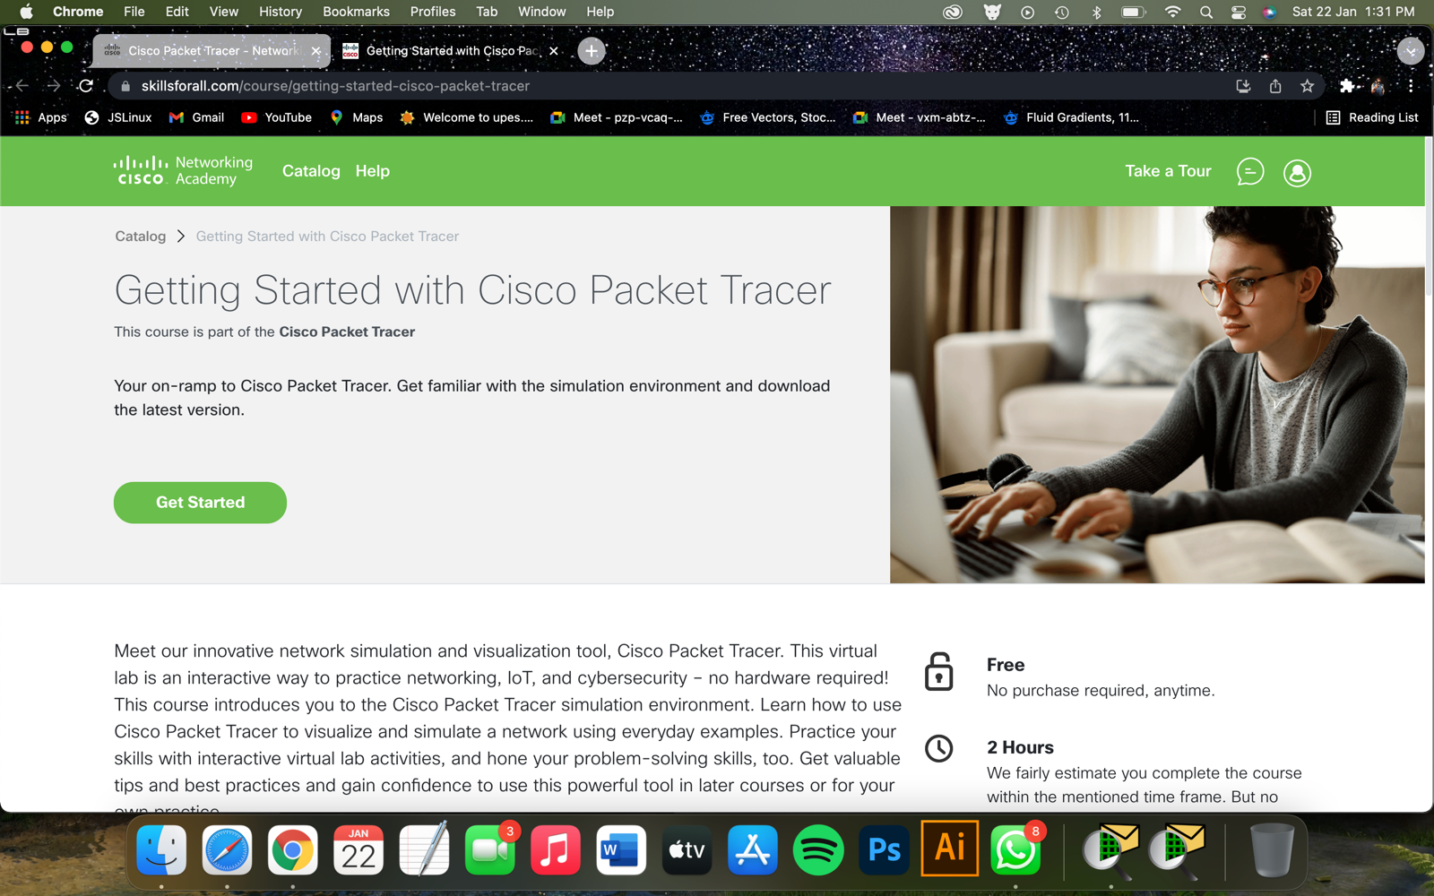

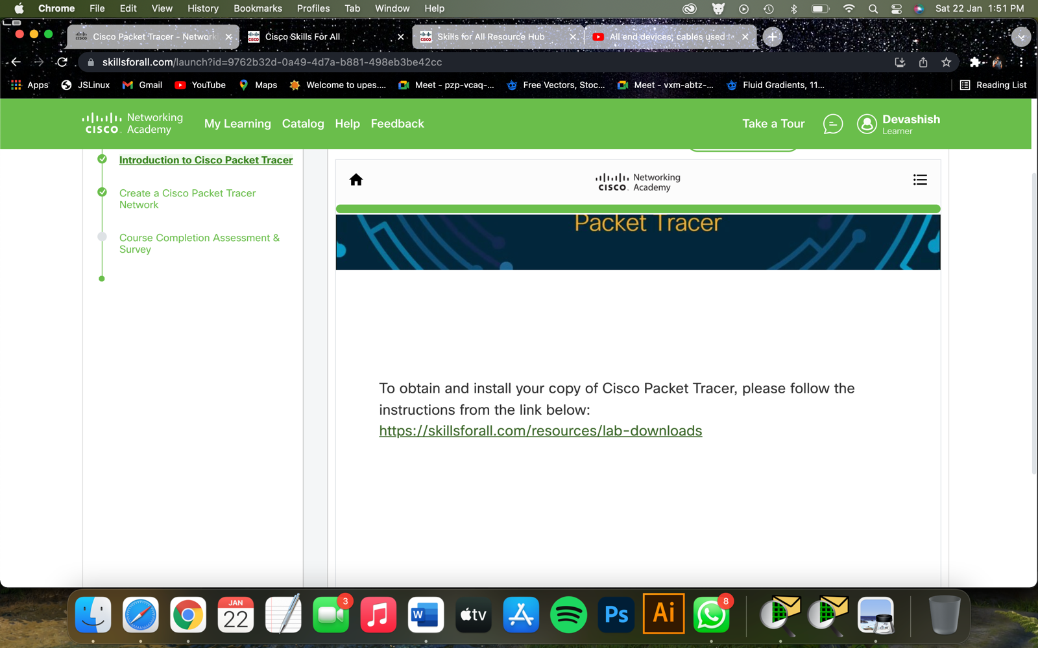

<https://skillsforall.com/resources/lab-downloads>

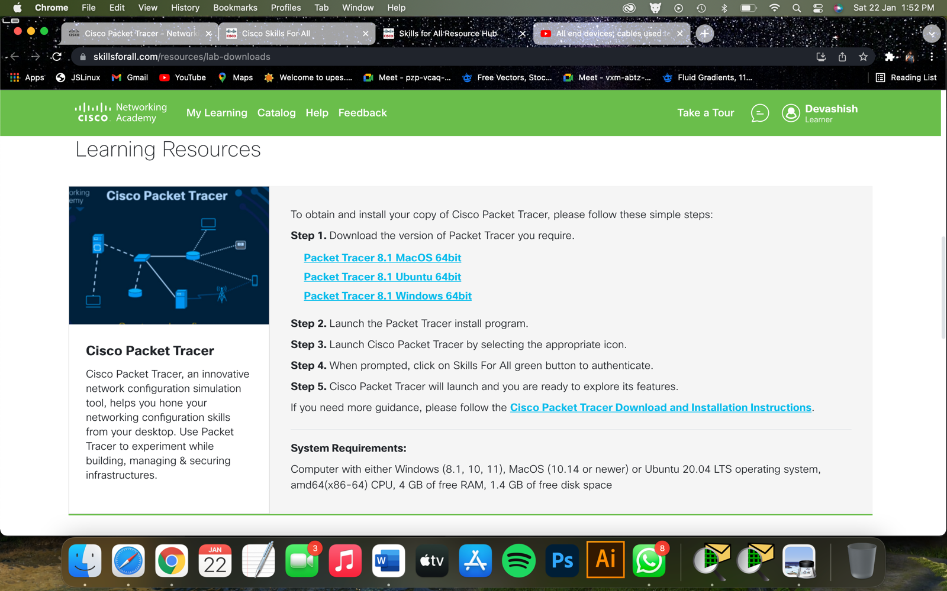

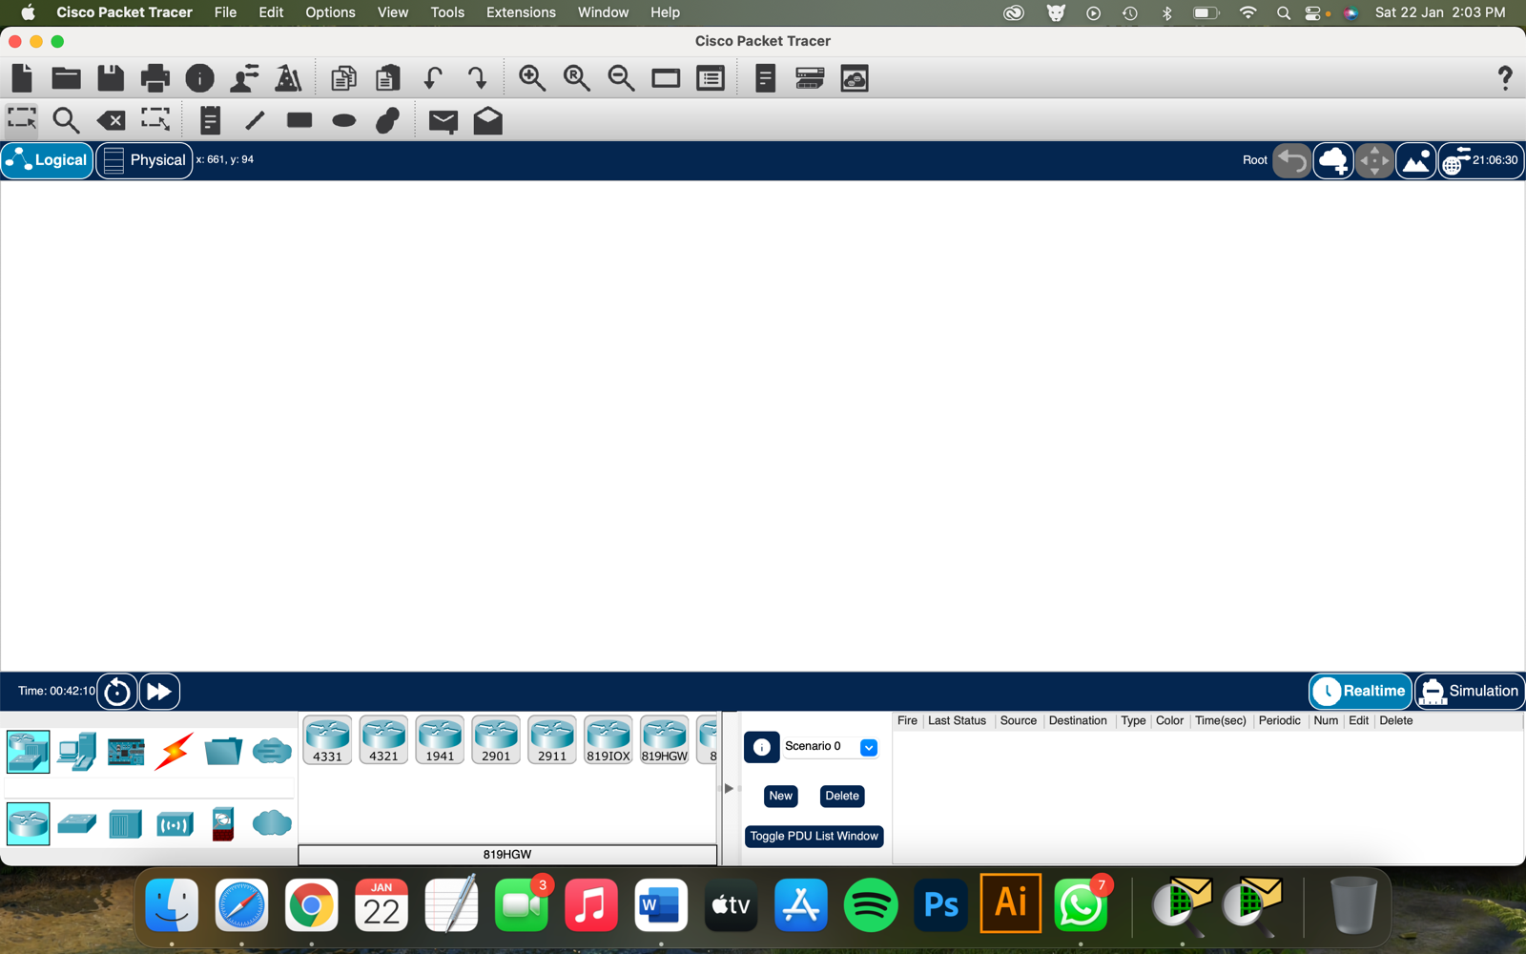

Task 1: Make a connection of 20 PCs using a switch and wires.

Screenshots :-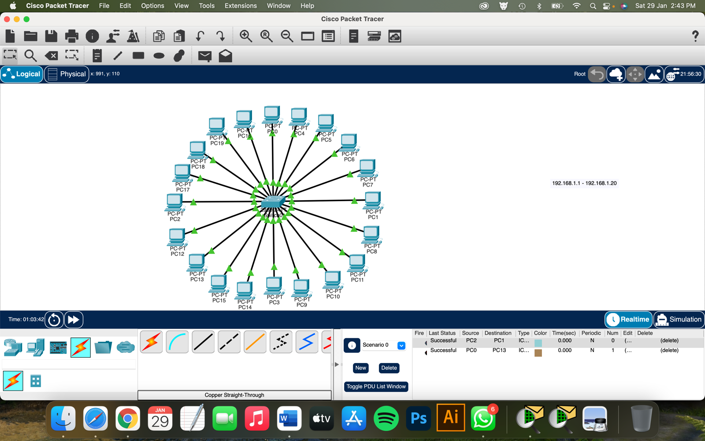

Task 2 : Assign every PC a IP address ranging from 192.168.1.1 to 192.168.1.20

Screenshot:

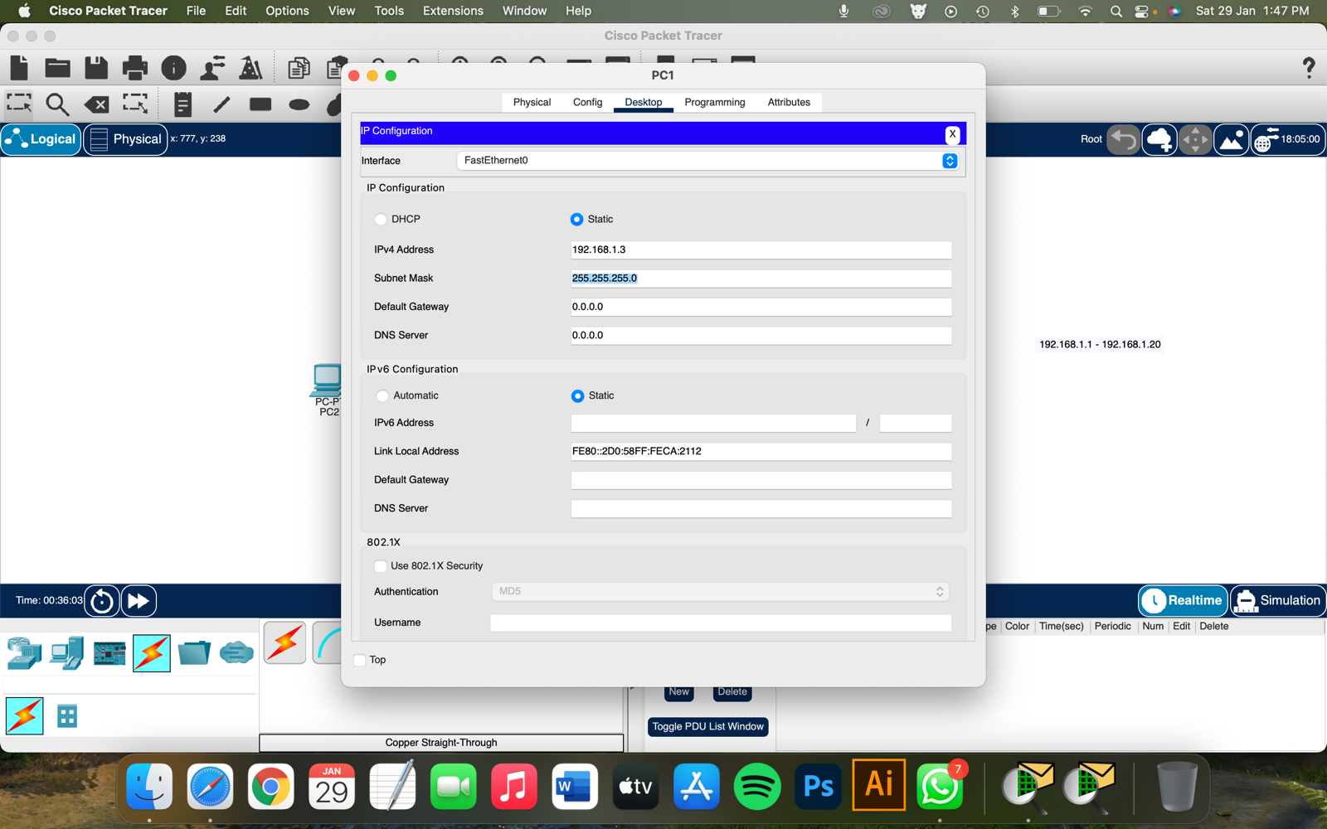

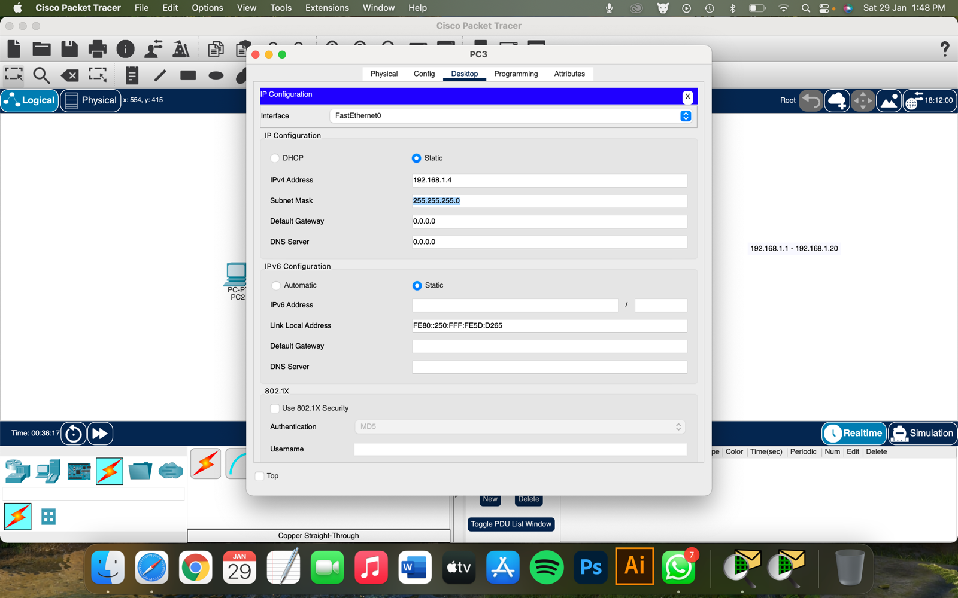

Task 3: Checking the connection by using ping command in cmd prompt

Screenshot: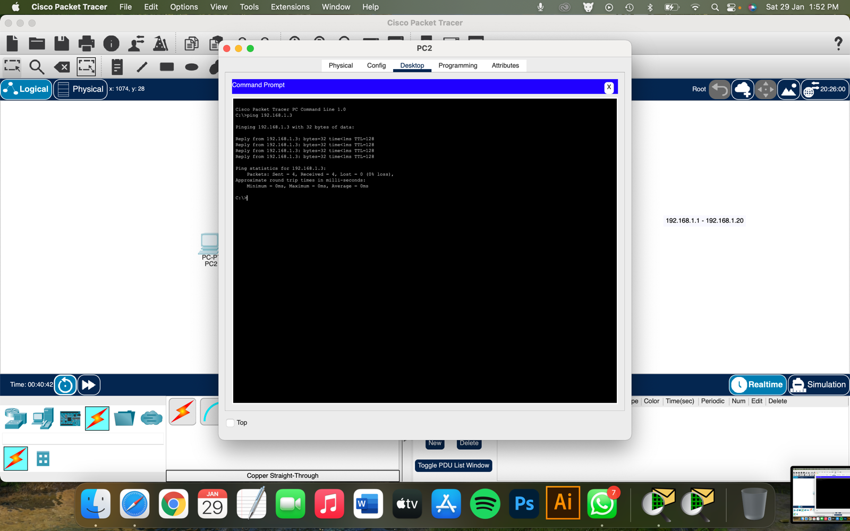



Task 4: Transferring PDU from one PC to another PC through the connection, in simulation mode

Screenshot: 

